**CSCE 606 Project: Iteration 0**

**Team Name: AppleSauce**

**Team Members:**

Amulya Agarwal

Piyush Blaggan  
Yerania Hernandez

Siru Li

Kevin Nguyen

Yang Yang

***Summary:***

The need for the CSCE 120 Self-Evaluation Exam is to evaluate incoming student’s knowledge on introductory programming concepts. Dr. Shell, being the main customer for this project, is in need of an application that students will take before the start of the course and will help him and the students understand how much they know and how much more work they need in order to be prepared for the course. As the course requires students to have little programming experience, he is looking for an application that could test various aspects in basic programming. The main stakeholders of this project will be the incoming students as they will use the system which will provide an evaluation on their readiness to take the course. Future professors will be able to decide what changes and adjustments in the introductory material should be made and covered at the beginning so that most of the students successfully complete this class.

The application we plan to develop will have two main aspects to it: (1) an administrative side for the professor and (2) a client side for the student. The administrative side is needed for the professor to keep track of whether students have taken the evaluation test. This side will be able to generate and send out the links for students to take the self-assessment. The client side for the student is for them to be able to see their self-evaluation questions and possibly their score and results. They should be able to decide if they are prepared for the course. With a variation of questions like multiple choice, fill in the blank, comparison of codes, etc. and a large quantity of questions being parameterized, we will be able to provide the application Dr. Shell is requesting along. The links for the interview, GitHub repository, and Pivotal Tracker can be found below as well.

***Links:***

* Video Interview: <https://youtu.be/JJERoh8ys0o>
* GitHub Repository: <https://github.com/hyerania/CSCE606-Project>
* Pivotal Tracker: <https://www.pivotaltracker.com/n/projects/2153120>

***User Stories:***

1. Feature: View the students that have registered from the database
   1. As an administrator
   2. So that I can see all students and their specific section
   3. I want to view the students that have registered for an account
2. Feature: View the course evaluation results
   1. As an administrator
   2. So that I can see which student has done the evaluation, which student has not done the evaluation, the score of the student, the time it took the student for the evaluation to be completed, and additional statistics on the results
   3. I want to view the individual results from the database along with additional statistics on the scores received
3. Feature: Generate access link and passcode for evaluation
   1. As an administrator
   2. So that I can email link to student’s email address
   3. I want to email the link and passcode of the evaluation to each student
4. Feature: Add questions of various types to database
   1. As an administrator
   2. So that I can continue adding different type of questions to the existing database
   3. I want to add various questions, including parameterized questions to the database
5. Feature: Remove a question from the database
   1. As an administrator
   2. So that I can remove a question that will no longer be used for evaluation from the database
   3. I want to remove an existing question from the database
6. Feature: Edit a question from the database
   1. As an administrator
   2. So that I can edit the parameters, choices, or options provided for a specific question
   3. I want to edit an existing question from the database
7. Feature: Customize correct answers and evaluation reports
   1. As an administrator
   2. So that I can customize evaluation reports to either train or evaluate students
   3. I want to be able to input correct answers for various kind of questions and enable/disable correct answers being displayed after students finished their evaluations.
8. Feature: Create an account using my student email
   1. As a student
   2. So that I can view my personalized evaluation and scores
   3. I want to be able to create an account to access my personalized evaluation
9. Feature: View instructions for evaluation
   1. As a student
   2. So that I can understand the details about the evaluation
   3. I want to view a screen with instructions and details about the evaluation
10. Feature: View one question at a time from the database
    1. As a student
    2. So that I can answer the question through multiple choice, fill in the blank, or other methods implemented
    3. I want to view an individual question at a time, without the option of returning to the previous question
11. Feature: View results of my personalized evaluation
    1. As a student
    2. So that I can understand the score of my evaluation
    3. I want to view the score of my personalized evaluation

***User Interface:***

*Administrative Manager Mockup and Storyboards*

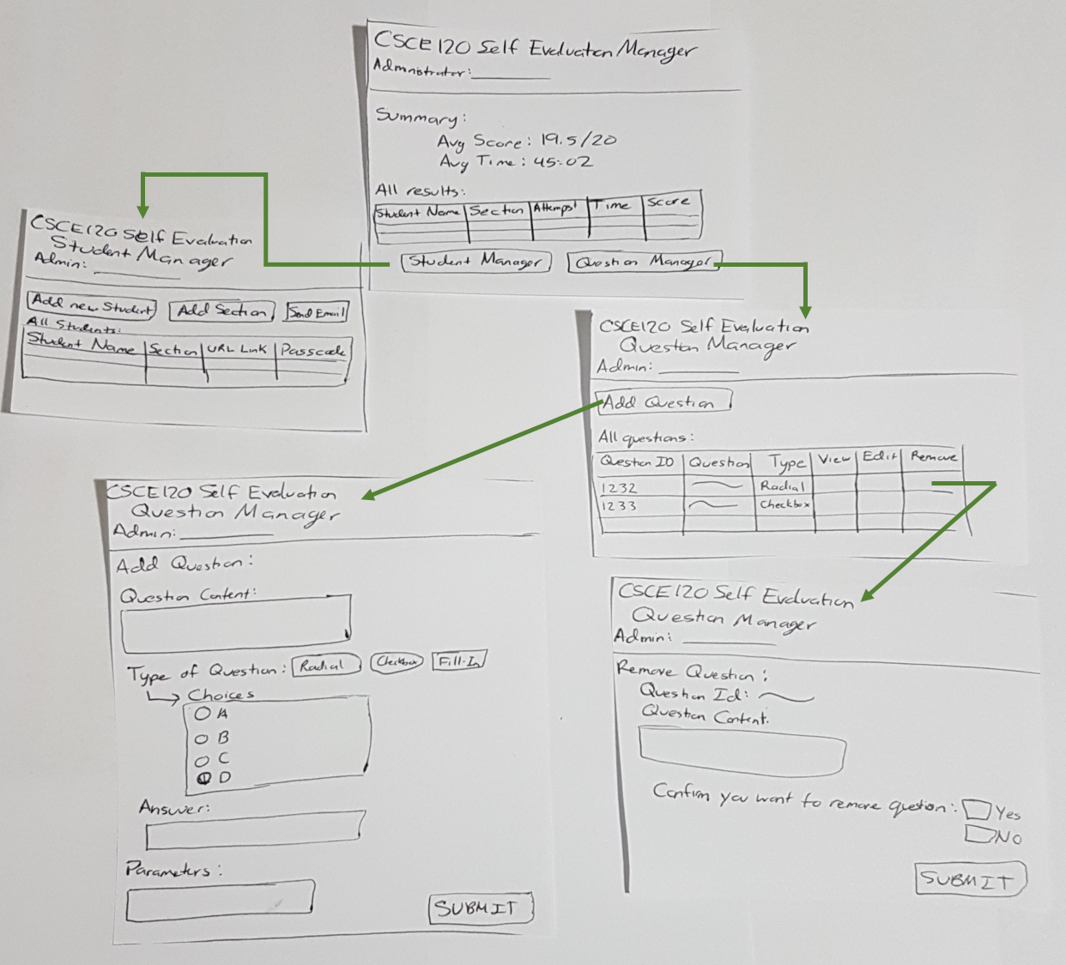

*Client Mockup and Storyboards:*

